**Brand Name : Obsession outlet**

Kids chairs

# Lumisource Micro Velvet Mitt Chair, Red

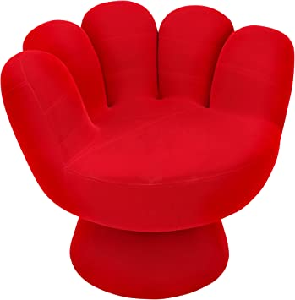**Description :**

Currently unavailable.  
We don't know when or if this item will be back in stock.

Top of Form

Color: **Red**

Bottom of Form

* comfortable
* great for all ages
* colorful addition to any room
* creates a cozy space in any room
* 32 L x 27.5 H x 32 W inches

**Rs:15,700**